**Name: Đinh Gia Bảo**

**Student ID: SE183741**

**Lab04   
Operating System**

**Submission :**

Upload the word or pdf file to cms describes some questions as

* Submit the **source of the shell script (*.sh)** and that **present the result of shell script program of Fibonacci in Shell.**

**Requirement :**

All the capture must be combination with full the windows **including your accounts on the windows and the Linux OS(if it is not, you will be taken 0 mark).** Should be use the capture in windows with jpg format to reduce the file size with your submitting.

Firstly, I will create a **Shell script program of Fibonacci** ( **fibonacci.sh** ) in **lab04** directory

**$ nano fibonacci.sh**

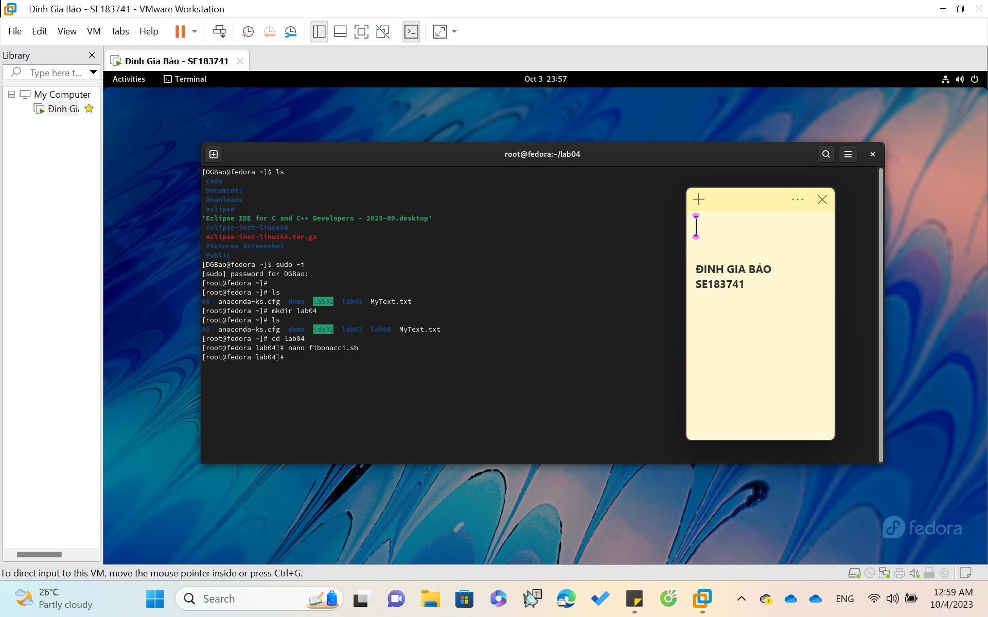

*create shell script file named “fibonacci”*

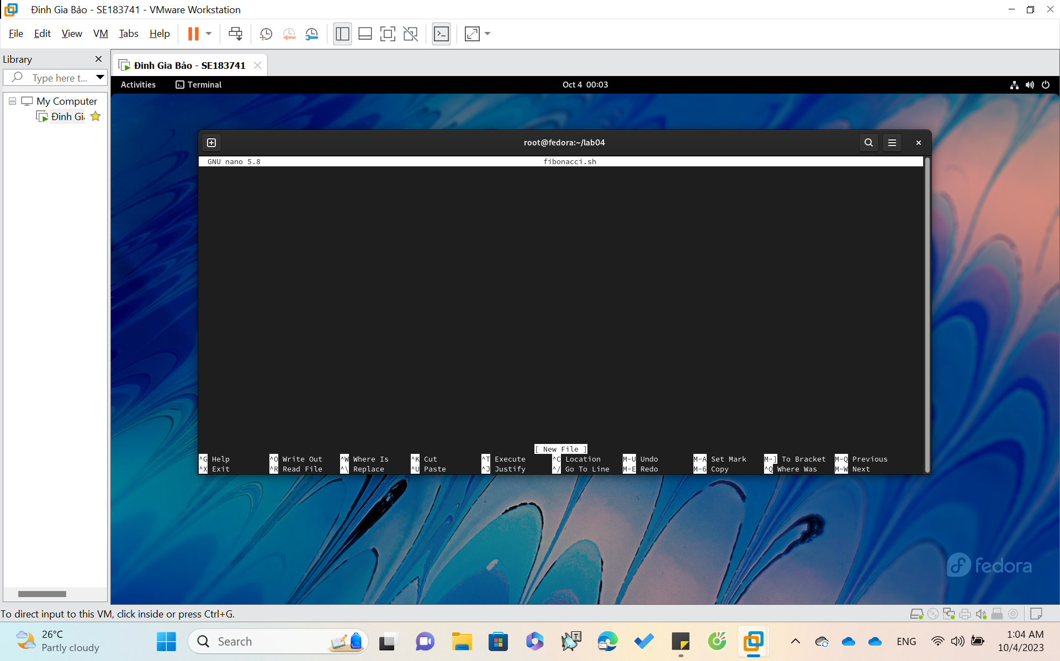

Secondly, I **code a Fibonacci program** and **save** the file.

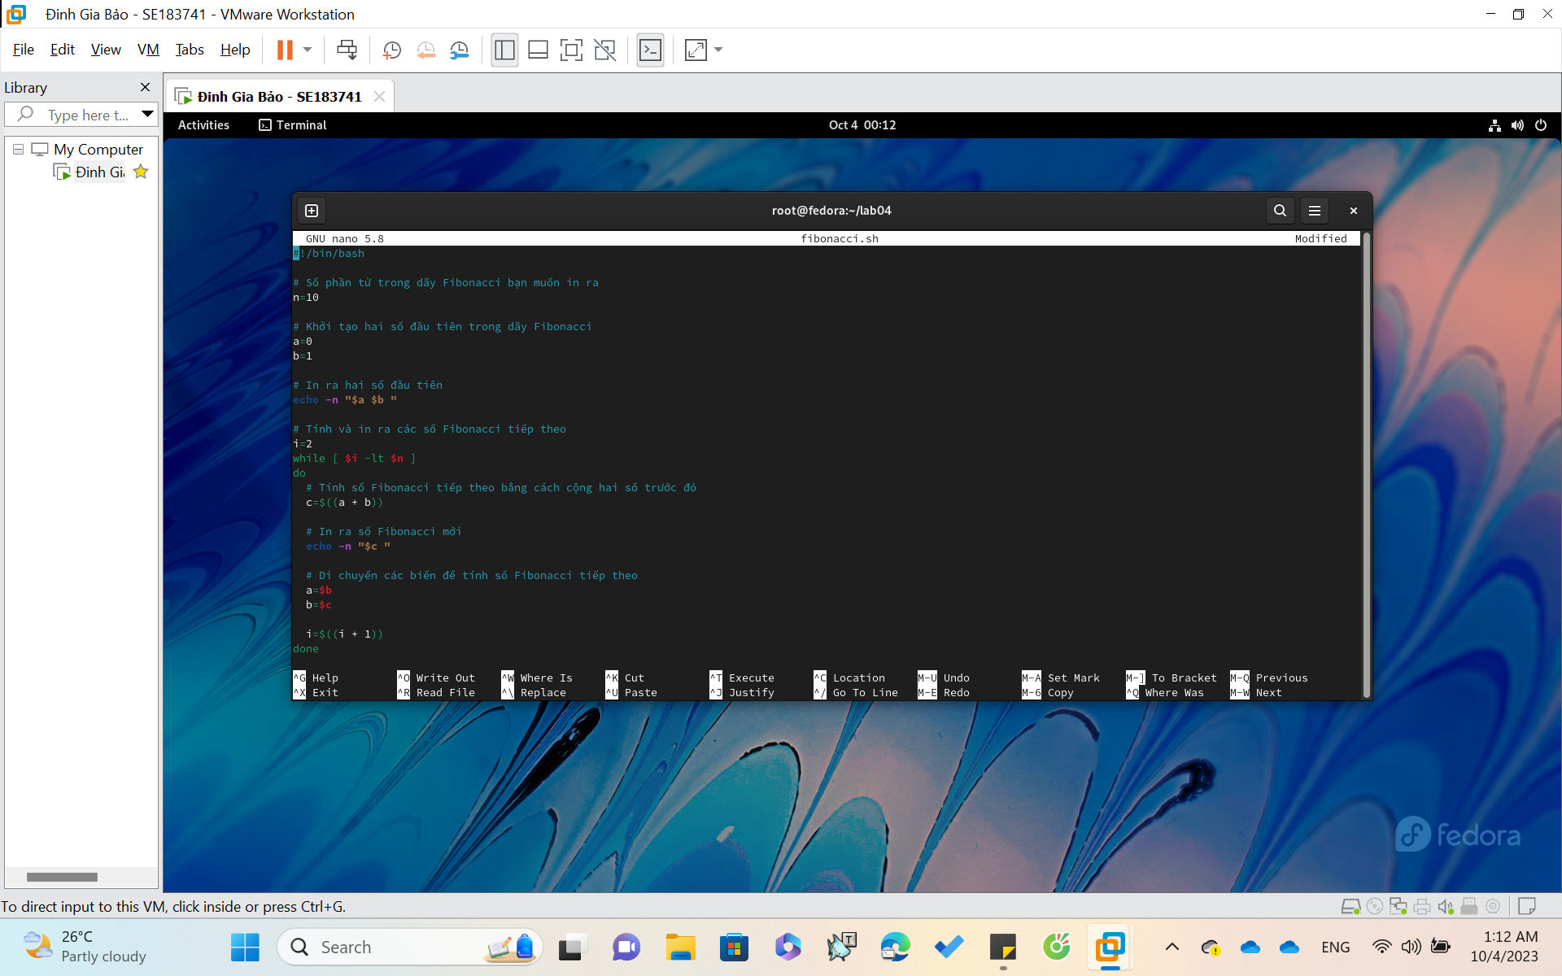

To save, **‘’ Ctrl+O ’’ -> click Enter**

To exit, Click **“ Ctrl + X ”**

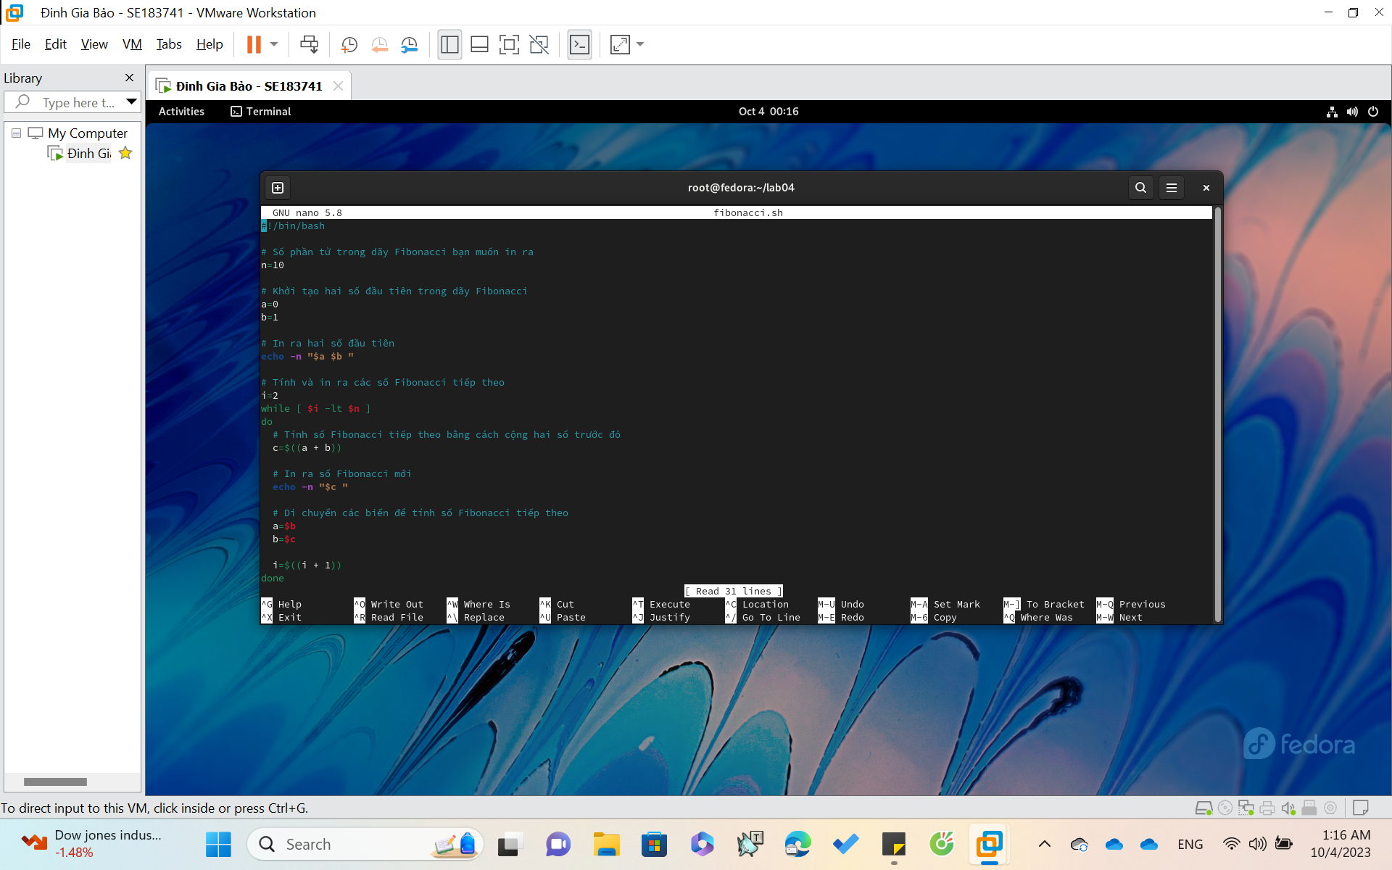

Thirdly, to **run** the shell script.

**Use command : $ ./filename.sh**

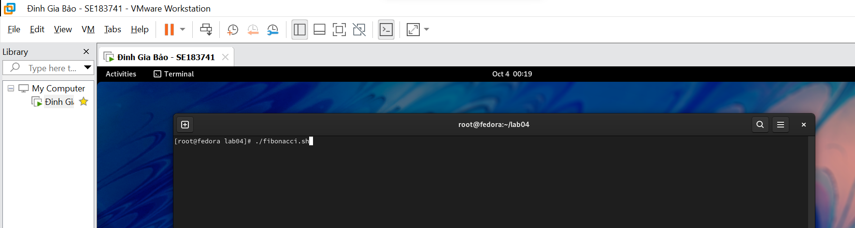

With the program above, type $ ./fibonacci.sh

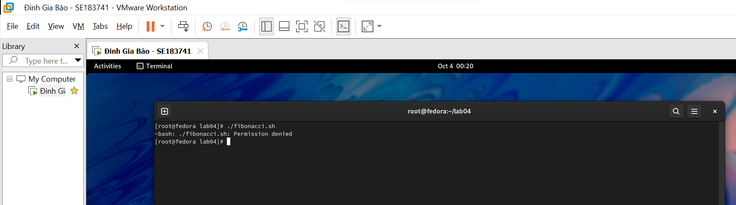

*It announces that the* ***fibonacci shell*** *needs permission.*

**Syntax for giving permission :**

**$ chmod 777 ./<filename.sh>**

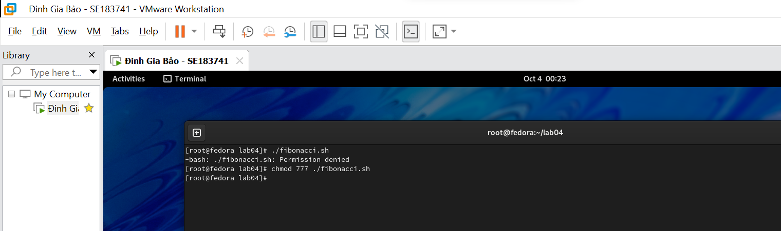

**Run the shell script again**

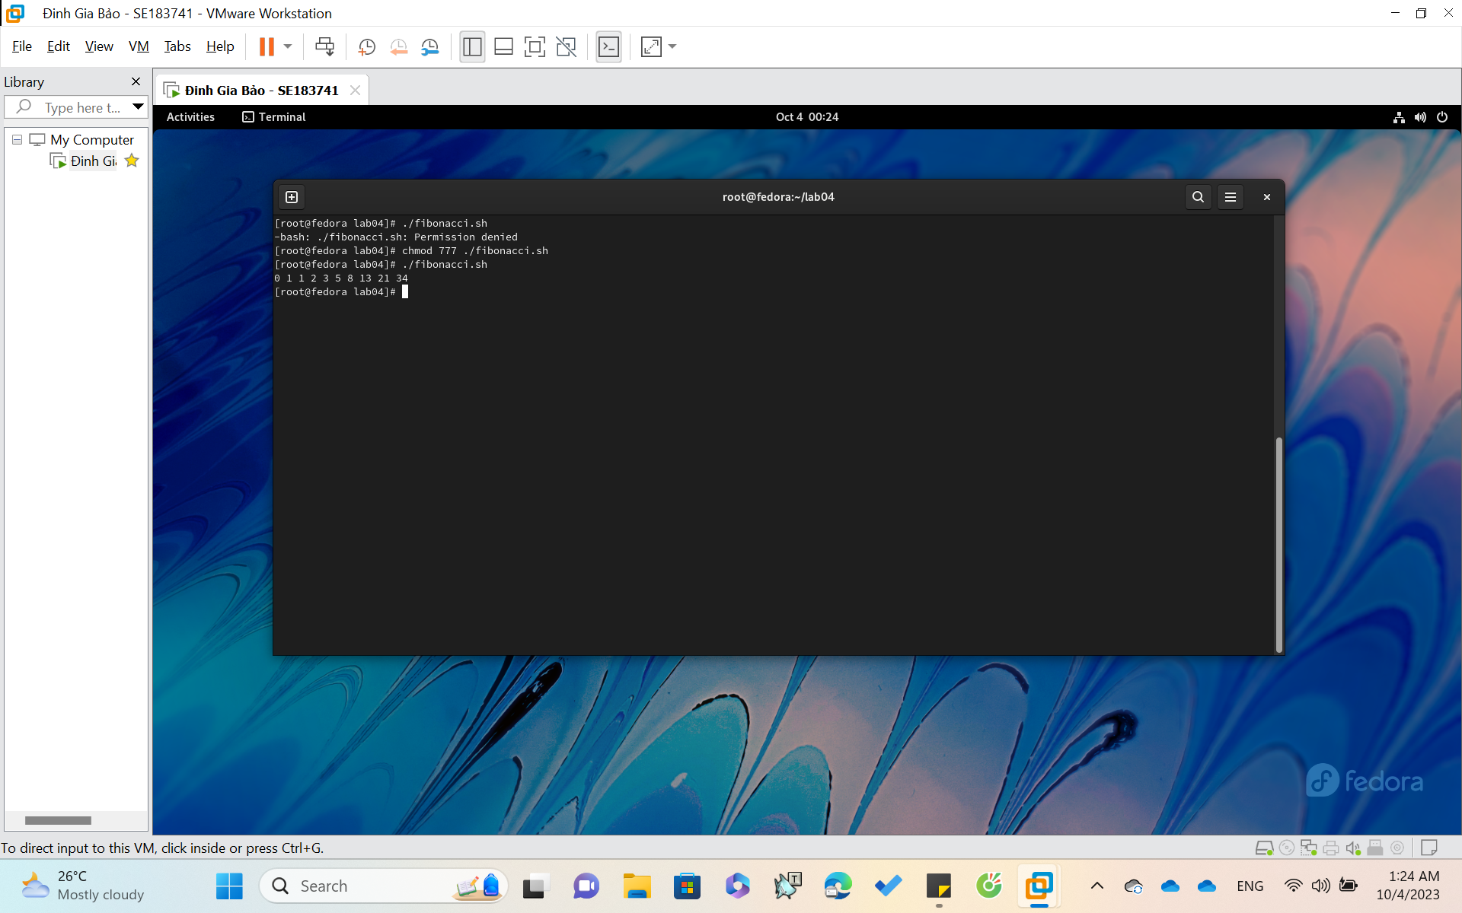

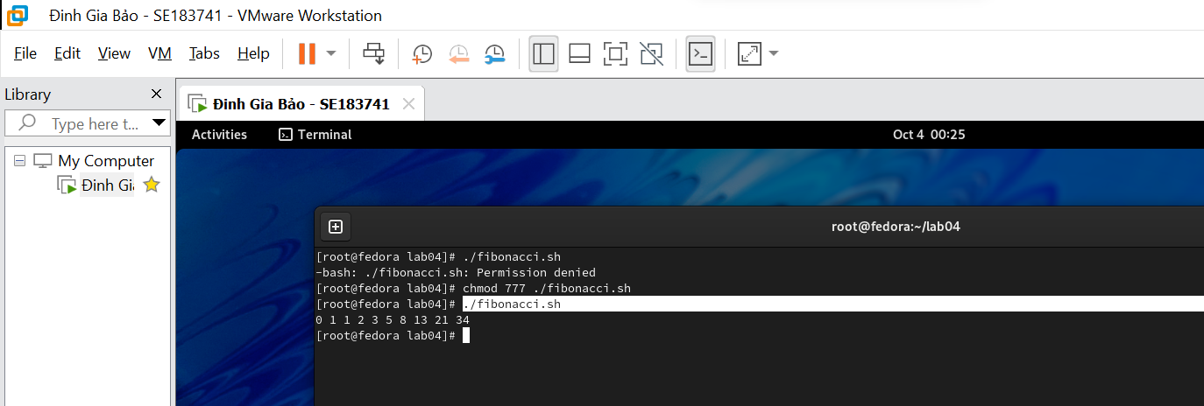

**Print the first 10 elements of fibonacci sequence.**

**END .**